Application for Nusoft MS Series URL Categorization Database Evaluation & License

Application procedure:

- Make sure that your unit meets the minimum memory requirement of 1 GB prior to this application. The system’s total memory is displayed under Monitor > Status > System Info. To increase the amount of memory, please contact your reseller for details.

- Fill out the “URL Categorization Database Evaluation & License Application Form” attached hereto and fax or email it to your reseller.

- A license key will be issued to you upon approval of your application.

- After receiving the license key, import it onto the device from URL Blocking > Configure > Setting to activate the URL categorization feature.
……………………………………………………………………………………………………

Attention:

- The evaluation of URL Categorization Database is applicable ONCE per unit.

- The evaluation period starts from the date of approval and expires after 7 days.

- You can obtain the product serial number from the bottom or the back of the unit as per the figure shown (circled in red):

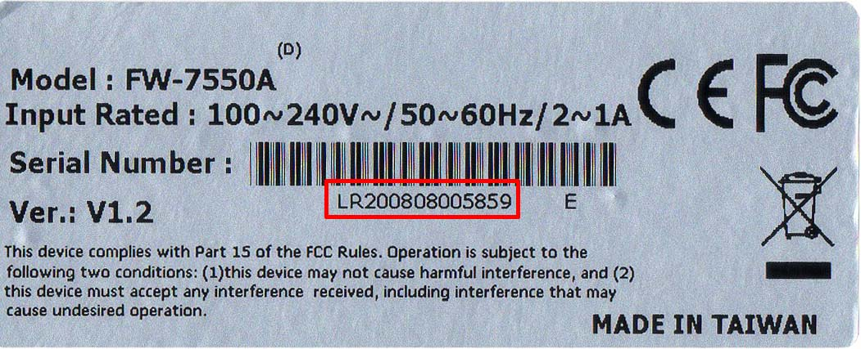
Picture Taken from NUS-MS1500G / NUS-MS5000

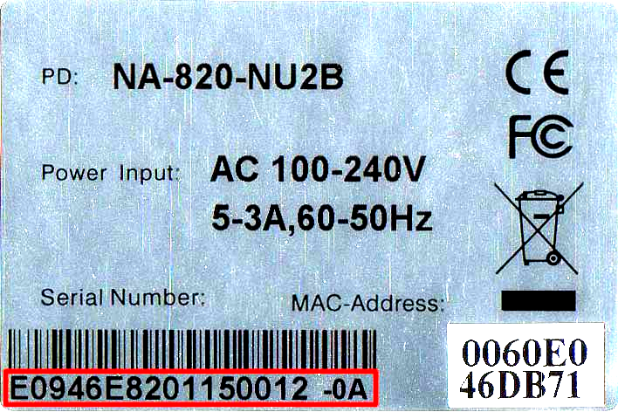
Picture Taken from NUS-MS3700 / NUS-MS2800

- The MAC address of your LAN interface is displayed under Monitor > Status > Interface.

Note: When filling out the application form, please specify the unit’s default LAN MAC address. If it has been changed and is no longer retrievable by any means, please contact us and we will obtain it using remote access to the unit.
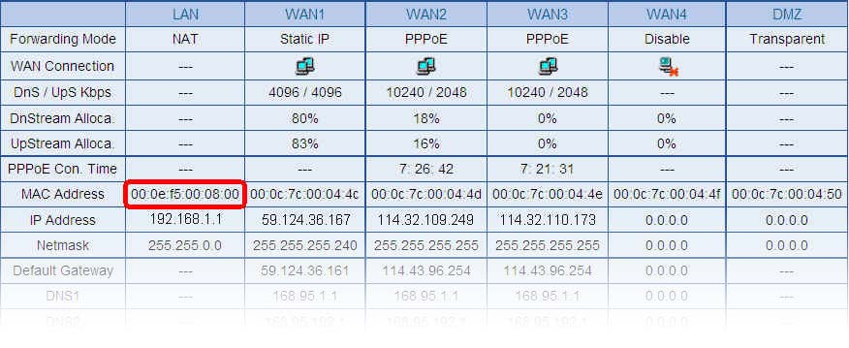

URL Categorization Database Evaluation & License Application Form for End Users

Applicant Information
Name | _________________  ( First Name / Surname ) | Company Name
Telephone No. |  | Email Address
Product Information
Application Type | □ Licensed for __ year(s) □ 7-days evaluation
Model Number |  | Product S/N
LAN MAC Address

Applicant’s Signature | ________________  ( First Name / Surname )  Date:_____________  ( month / day / year ) | Approver’s Signature | _________________  ( First Name / Surname )  Date:______________  ( month / day / year )
Note: The bordered fields are required.

